ITUE203: WEB DEVELOPMENT FRAMEWORKS 25CS106– Yana


Faculty of Technology and Engineering

Chandubhai S. Patel Institute of Technology (CSPIT) Department of Computer Science & Engineering

Laboratory manual
Academic Year | : | 2026-27 | Semester | : | 3rd

Practical - 14

PROBLEM STATEMENT :
Problem Definition: Develop an admin dashboard that displays user statistics, student count, event count and latest registrations. Restrict access to admin users only and show dynamic menu options based on role.

OBJECTIVE:
To develop a secure, role-based admin dashboard that displays user statistics, total student count, total event count, and latest registrations dynamically from the database. Restrict dashboard access to authorized administrators and display menu options according to the user's role.
OUTPUT:
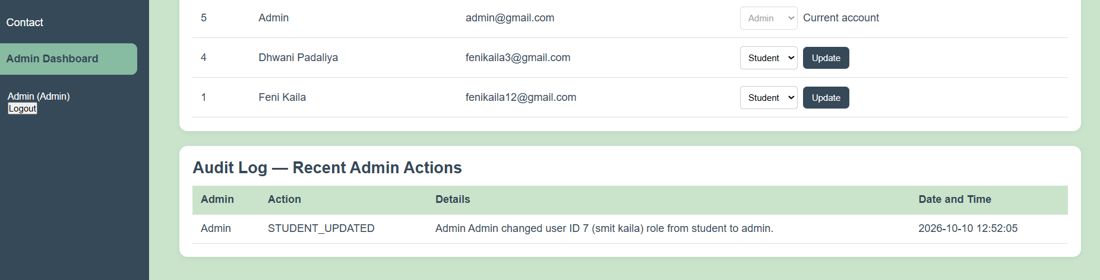
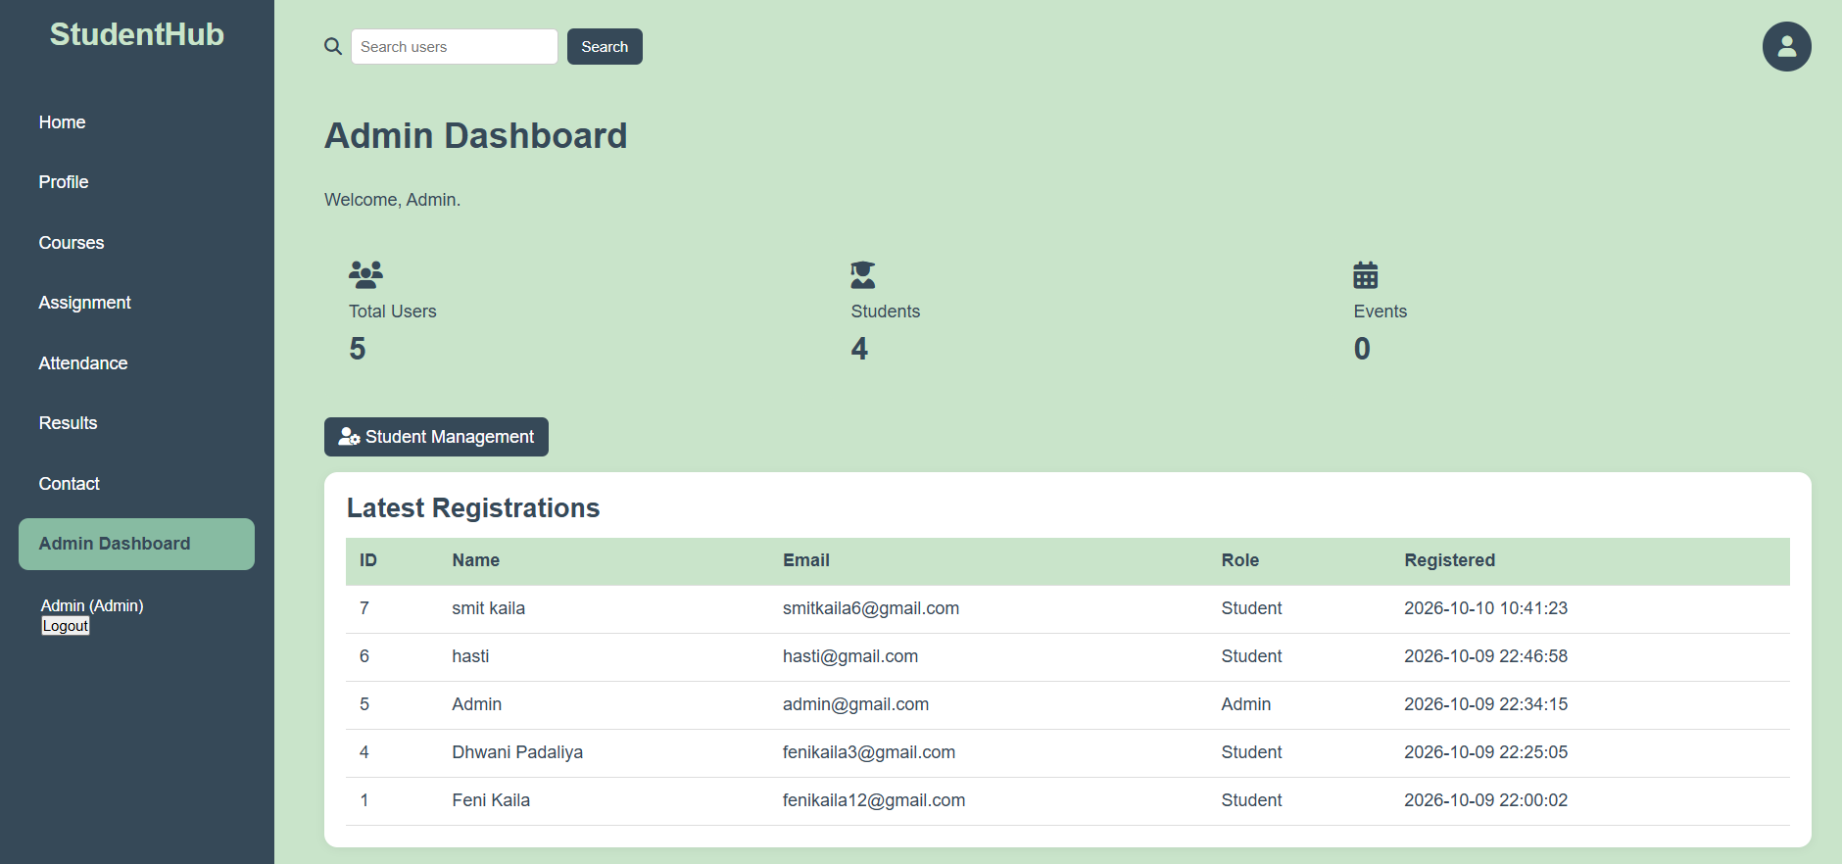
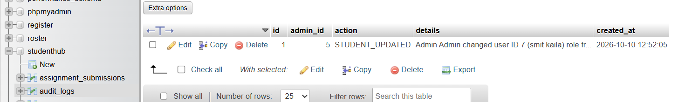

LEARNING OUTCOME:
• Develop an admin dashboard to display dynamic statistics and recent registration details.
• Retrieve and display user, student, event, and registration data from a MySQL database using PHP.
• Implement role-based access control to restrict dashboard access to authorized administrators.
• Display dynamic navigation menus based on the logged-in user's role.
• Apply session management and access-control techniques to improve application security.

